1

SRI VENKATESWARA COLLEGE OF ENGINEERING

PENNALUR, SRIPERUMBUDUR

IT16301-COA

UNIT – 5 MEMORY AND I/O SYSTEMS (PART-II)

ACCESSING I/O DEVICES:
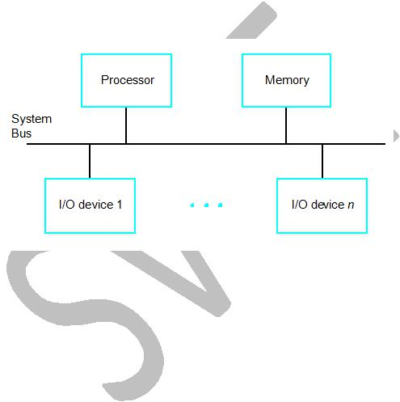

A simple arrangement to connect I/O devices to a computer is to use a single bus arrangement, as shown in the below figure.

The system bus consists of 3 lines:
- Data lines – carry data

- Control lines – carry control signals

- Address lines – carry address

The bus enables all the devices connected to it to exchange information. Each I/O device is assigned a unique set of addresses. When the processor places a particular address on the address lines, the device that recognizes this address responds to the commands issued on the control lines. The processor requests either a read or write operations, and the requested data are transferred over the data lines.

2

Memory Mapped and Isolated I/O:

Memory mapped I/O – I/O devices and memory share the same address space, the arrangement is called memory-mapped I/O.

Isolated I/O – I/O devices and memory have separate address space.

One advantage of a separate I/O address space is that I/O devices deal with fewer address
lines.

Difference between Memory mapped and Isolated I/O:
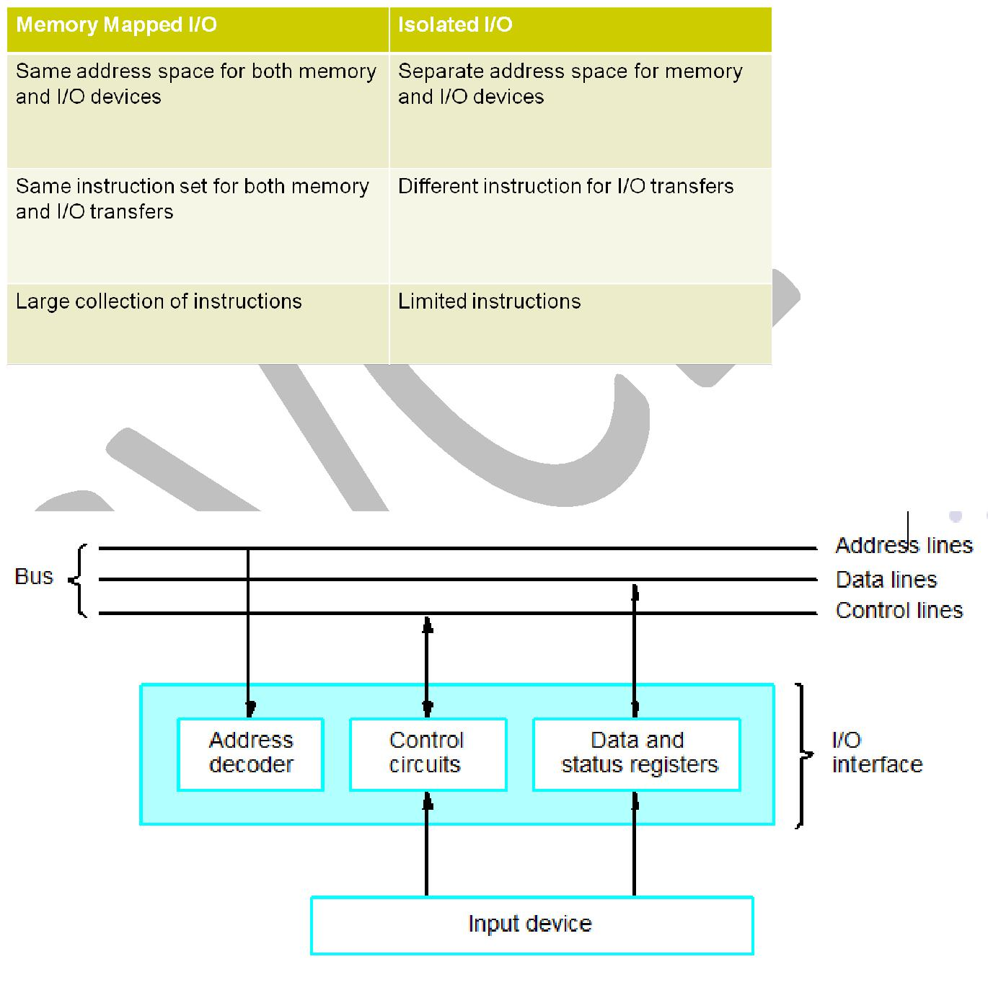

I/O interface for an input device:

The below figure illustrates the hardware required to connect an I/O device to the bus.

Address decoder: It enables the device to recognize its address when this address appears on the address lines.

Control circuits: Required to co-ordinate the I/O transfers.

3

Data and status registers: Data register holds the data being transferred to or from the processor. Status register contains the information relevant to the operation of the I/O device. Both data and status registers are connected to the data bus.

I/O interface: The address decoder, the data and status registers, and the control circuitry constitute the device’s interface circuit.

MECHANISMS TO IMPLEMENT I/O OPERATIONS:
- Programmed I/O – processor polls the device repeatedly.

- Interrupt-driven I/O

- Direct Memory Access (DMA)


Programmed I/O:

In programmed I/O, the processor repeatedly checks a status flag to achieve the required synchronization between the processor and an input or output device. Here the processor polls the device

Interrupt driven I/O:

In case of interrupts, synchronization is achieved by having the I/O device send a special signal over the bus whenever it is ready for a data transfer operation.

DMA – Direct memory access:

DMA is a technique used for high-speed I/O device. It involves having the device interface transfer data directly to or from the memory, without continuous involvement by the processor.

PROGRAMMED I/O:

The CPU has direct control over I/O.

CPU does the following during I/O operation,

- Sensing status
- Read/write commands
- Transferring data

Disadvantage: CPU waits for I/O module to complete operation. This wastes CPU time significantly.

Programmed I/O steps (as given in below diagram):

- CPU requests I/O operation

- I/O module performs operation

- I/O module sets status bits (whether I/O device is ready or not for the I/O operation)

- CPU checks status bits periodically - polling

4
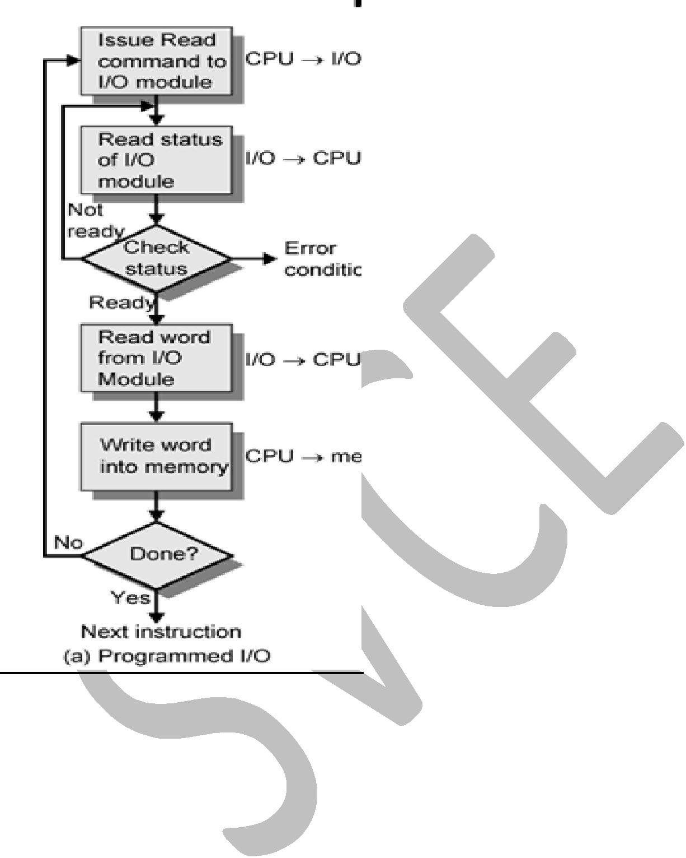

Polling:

CPU checks the status of I/O repeatedly. CPU clock cycles are wasted. The repeated checking is called as polling.

Registers in keyboard and display interfaces (programmed I/O):

Let us consider a simple example of I/O operations involving a keyboard and a display device in a computer system. The four registers are shown in the below figure are used in the data transfer operations.

STATUS register – contains two control flags SOUT and SIN, which provides status information for the keyboard and display unit. The two flags KIRQ and DIRQ are used in conjunction with interrupts.

CONTROL register - KEN and DEN bits. KEN – Keyboard interrupt enable. DEN – Display interrupt enable.

DATAIN register – Data from the keyboard are made available in DATAIN register.

5

DATAOUT register – Data to the display are stored in the DATAOUT register.

For an input device such as a keyboard, a status flag, SIN is included in the STATUS register. This flag is set to 1 when a character is entered in the keyboard and cleared to 0 once this character is read by the processor. Hence, by checking the SIN flag, the software can ensure that it is always reading valid data. This is often accomplished in a program loop that repeatedly reads the status register and checks the state of SIN. When SIN becomes equal to 1, the program reads the input data register. A similar procedure can be used to control output operations using an output status flag, SOUT.
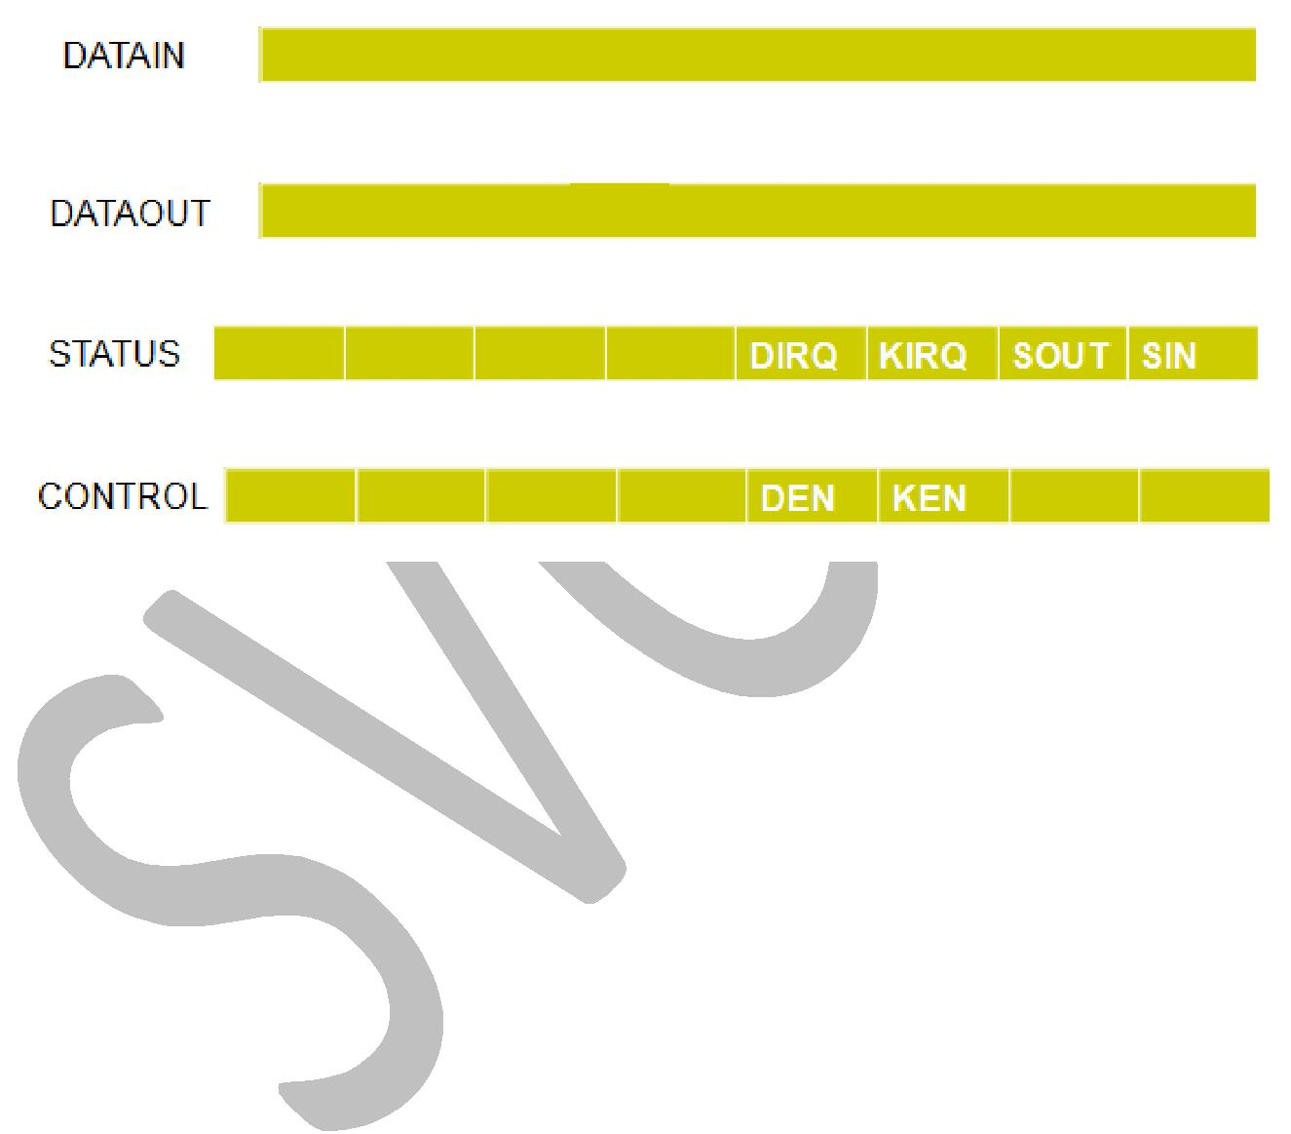

INTERRUPT DRIVEN I/O:

In programmed controlled I/O, CPU clock cycles are wasted as the CPU repeatedly checks the status SIN and SOUT registers without doing any useful work.

Interrupt driven I/O overcomes the disadvantage of Programmed I/O. Processor does not wait for the I/O device rather I/O device interrupts the processor when it is ready.

In interrupt driven I/O, I/O device alert the processor when it becomes ready. It can do so by sending a hardware signal called an interrupt to the processor. One of the bus control lines, called IR – Interrupt Request line, is used to send the interrupt by I/O to processor. IA – Interrupt Acknowledgement, is used to inform the device that its interrupt request has been recognized by the processor. ISR – Interrupt Service Routine executed in response to IR, which is similar to a function call.

Since the processor is no longer required to continuously check the status of external devices, it can use the waiting period to perform other useful functions. Indeed, by using interrupts, such waiting periods can ideally be eliminated.

Concept of Interrupts:

Below figure shows the transfer of control through the use of interrupts. The routine executed in response to an interrupt request is called the interrupt-service routine (ISR). Interrupts are similar

6

to subroutine calls. Assume that an interrupt request arrives during execution of instruction i as shown in the below figure. The processor first completes execution of instruction i. Then, it loads the program counter with the address of the first instruction of the interrupt-service routine (ISR). After execution of the interrupt service routine, the processor has to come back to instruction i+1. Therefore, when an interrupt occurs, the current contents of the PC, which points to instruction i+1, must be put in temporary storage in a known location. A Return-from-interrupt instruction at the end of the interrupt service routine reloads the PC from that temporary storage location, causing execution to resume at instruction i+1.
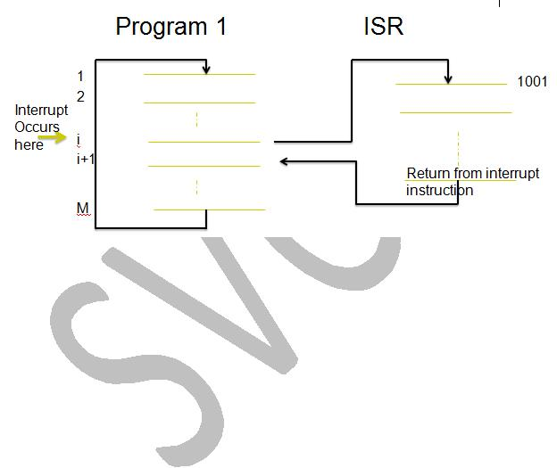

Enabling and Disabling interrupts:

What the processor will do when it receives an interrupt while executing another interrupt(ISR)?

1st solution:

Interrupt-disable instruction as the first instruction in the interrupt service routine, the programmer can ensure that no further interruptions will occur until an Interrupt-enable instruction is executed. Typically, the Interrupt-Enable instruction will be the last instruction in the interrupt-service routine before the Return-from-interrupt instruction.

2nd solution:

Processor status register (PS) has Interrupt-enable bit, which indicates whether interrupts are enabled. If Interrupt-enable bit is 1, interrupt request will be accepted. If Interrupt-enable bit is 0, interrupt request will not be accepted. So, we can

- Disable interrupt – when executing ISR (ie) interrupt-enable bit set to 0

- Enable interrupt – After finishing ISR (ie) interrupt-enable bit set to 1

- This ensures only one Interrupt is processed at a time

3rd solution:

Processor has a special interrupt-request line for which interrupt-handling circuit responds only to the leading edge of the signal. Such a line is said to be edge-triggered. In this

7

case, the processor will receive only one request, regardless of how long the line is activated.
Hence, there is no danger of multiple interruptions.

In detail, summarize the sequence of events involved in handling an interrupt request from a single device:

- The device raises an interrupt request (IR).

- The processor is interrupted when executing some other (i) instruction.

- Processor finishes executing that (i) instruction.

- Interrupts are disabled by changing the control bits in the PS register. (id) sets Interrupt enable bit to 0.

- The I/O device is informed that its request has been recognized by sending interrupt acknowledgement (IA) signal to I/O (Acknowledgement).

- Save the current PC and PS register values in stack.

- Update PC = ISR address

- The action requested by the interrupt is performed by the interrupt service routine. (ie) execute the ISR.

- Interrupts are enabled by changing the control set interrupt enable bit to 1.

- Return-from-interrupt instruction is executed.

- Restore the PC and register values from stack.

In short, summarize the sequence of events involved in handling an interrupt request from a single device:

- The device raises an interrupt request.
- The processor interrupts the program currently being executed.
- Interrupts are disabled by changing the control bits in the PS.
- The device is informed that its request has been recognized.
- The action requested by the interrupt is performed by the interrupt-service routine.
- Interrupts are enabled and execution of the interrupted program is resumed.

Handling multiple devices:

Let us now consider a situation where a number of devices capable of initiating interrupts are connected to the processor. Because these devices are independent, there is no definite order in which they will generate interrupts. For example, device X may request an interrupt while an interrupt caused by device Y is being serviced, or several devices may request interrupts at exactly the same time. This gives rise to a number of questions:
- How can the processor recognize the device requesting an interrupt?

- Given that different devices are likely to require different interrupt-service routines, how can the processor obtain the starting address of the appropriate routine in each case?

- Should a device be allowed to interrupt the processor while another interrupt is being serviced?

8

- How should two or more simultaneous interrupt requests be handled?

Polling:

The first two questions can be answered by using polling.

The simplest way to identify the interrupting device is to have the interrupt-service routine poll all the I/O devices connected to the bus. The first device encountered with its IRQ bit set is the device that should be serviced. The processor recognizes the device requesting an interrupt by above polling scheme.

The polling scheme is easy to implement.
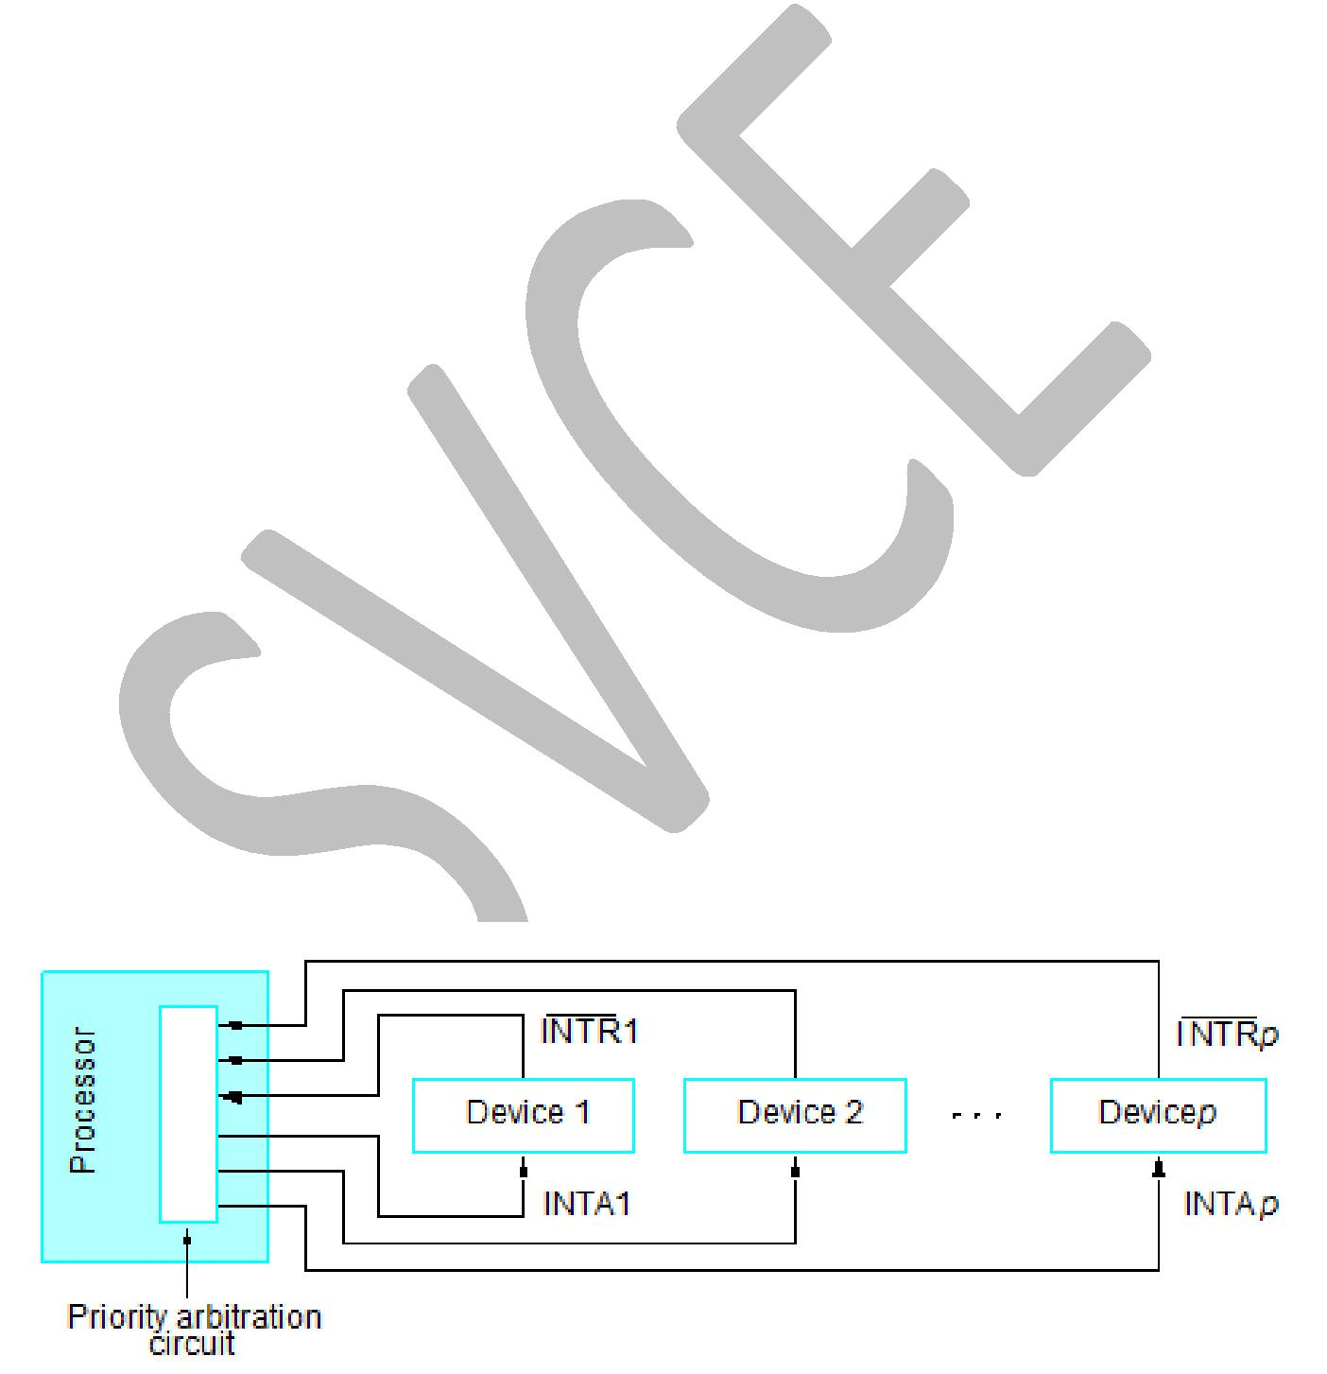

Disadvantage is the time-spent interrogating the IRQ bits of all the devices that may not be requesting any service. Alternative approach is to use vectored interrupts.

Vectored Interrupts:

The first two questions can be answered by using vectored interrupts.

To reduce the time involved in the polling process, a device requesting an interrupt may identify itself directly to the processor. Then, the processor can immediately start executing the corresponding interrupt-service routine.

A device requesting an interrupt can identify itself by sending a special code to the processor over the bus. This enables the processor to identify individual devices. The code supplied by the device may represent the starting address of the interrupt-service routine for that device. The code is called as interrupt-vector code.

Interrupt nesting:

Should a device be allowed to interrupt the processor while another interrupt is being serviced?

Yes, an interrupt request from high-priority device should be accepted while the processor is servicing another request from a lower-priority device.

This requires I/O devices be organized in a priority structure.

A multiple-level priority organization means that during execution of an interrupt-service routine, interrupt requests will be accepted from some devices but not from others, depending upon the device’s priority.

9

A multiple-level priority scheme can be implemented easily by using separate interrupt-request and interrupt-acknowledge lines for each device as shown in the above figure. Each of the interrupt-request lines is assigned a different priority level. Interrupt requests received over these lines are sent to a priority arbitration circuit in the processor. A request is accepted only if it has a higher priority level than that currently assigned to the processor.

Each device has a separate IR and IA line

- Each IR line has different priority levels

- Priority arbitration circuit -> accepts interrupt when its priority is higher than the currently executing interrupt

Simultaneous Requests:

Let us now consider the problem of simultaneous arrivals of interrupt requests from two or more devices. The widely used scheme is to connect the devices to form a daisy chain, as shown in the below figure (a). The interrupt-request line INTR is common to all devices. The interrupt-acknowledgement line, INTA, is connected in a daisy chain fashion, such that the INTA signal propagates serially through the devices. When several devices raise an interrupt request and the INTR line is activated, the processor responds by setting the INTA line to 1. This signal is received by device 1. Device 1 passes the signal on to device 2 only if it does not require any service. If device 1 has pending request for interrupt, it blocks the INTA signal and proceeds to put its identifying code on the data lines. Therefore, in the daisy-chain arrangement, the device that is electrically closest to the processor has the highest priority. The second device along the chain has the second highest priority, and so on.

The main advantage of daisy chain as seen in figure (a) over the multiple-level priority scheme is that daisy chain requires fewer wires than the individual connections in multiple-level priority scheme.

The scheme shown in figure (b), combines both schemes to produce the more general structure. Devices are organized in groups, and each group is connected at a different priority level. Within a group, devices are connected in a daisy chain. This organization is used in many computer systems.

10
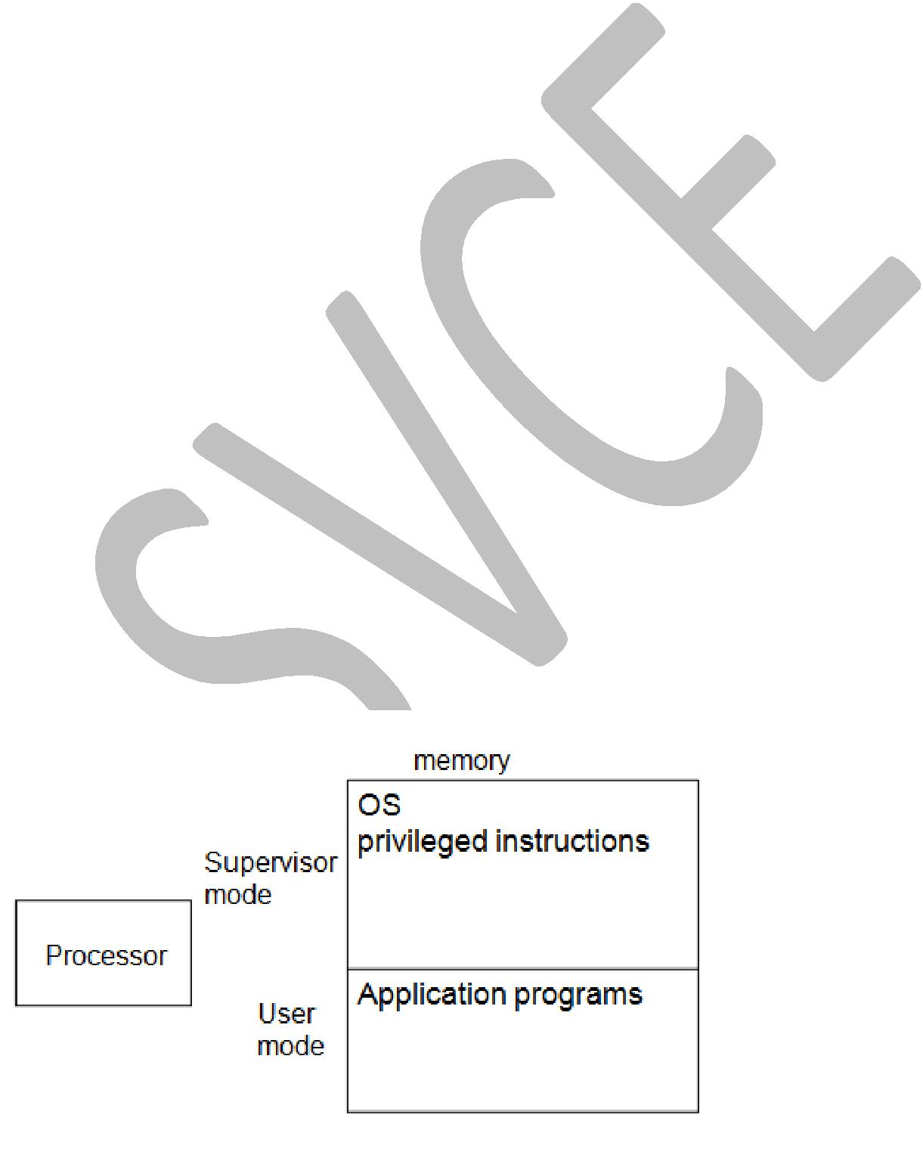

Privileged Instructions:

The below figure shows the two modes in which the processor operates in,

- User mode
- Supervisor mode

In user mode, application programs are executed by the processor.

In supervisor mode, privileged instructions and OS are executed by the processor.

11

DIRECT MEMORY ACCESS:

Overcomes overhead of Polling and Interrupts.

A special control unit may be provided to allow transfer of a block of data directly between an external device and the main memory, without continuous intervention by the processor – direct memory access (DMA).

Direct Memory Access - takes the work of CPU and used in transferring bulk data.
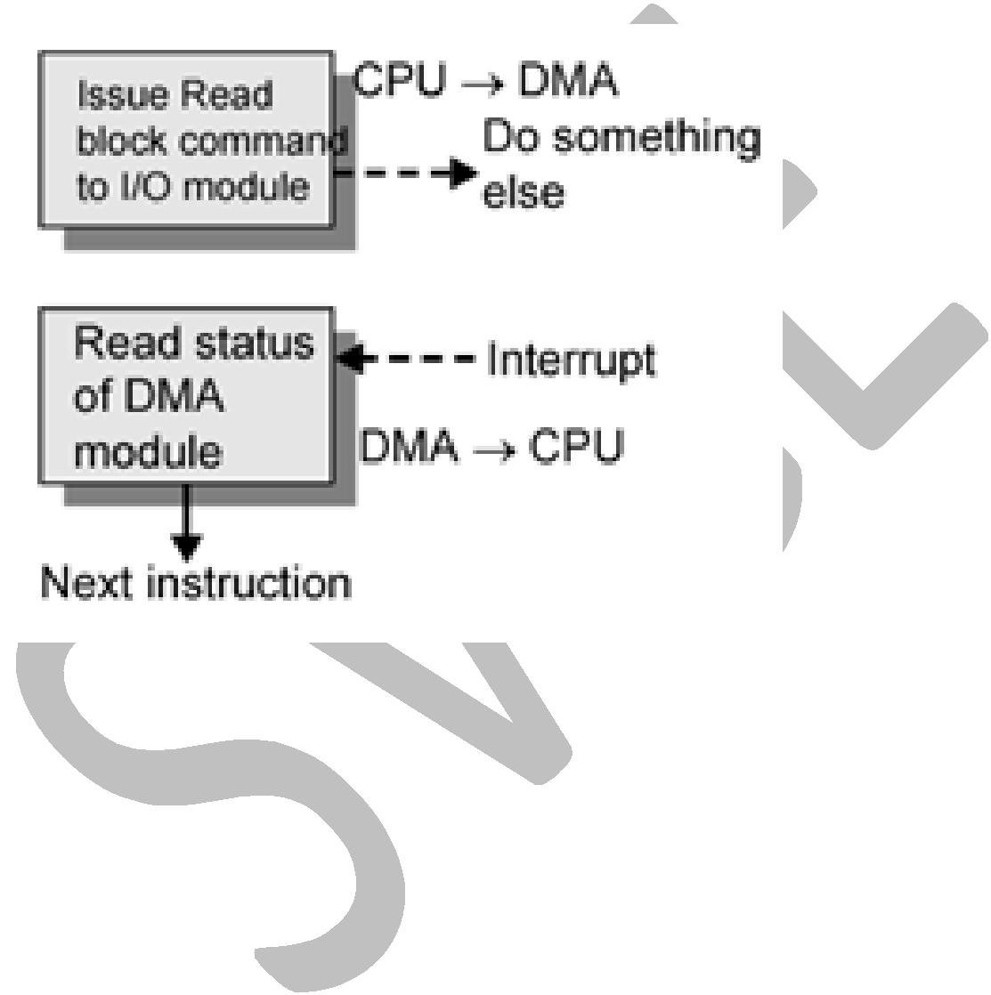

DMA procedure:

- Processor sends the 1. starting address, 2. the number of data, and the 3. direction of transfer to DMA controller.

- Processor suspends the application program requesting DMA, starts DMA transfer, and starts another program.

- After the DMA transfer is done, DMA controller sends an interrupt signal to the processor.
- The processor puts the suspended program in the Runnable state.

The DMA controller performs the functions that would normally be carried out by the processor when accessing the main memory.

To initiate the transfer of a block of words, the processor sends the starting address, the number of words in the block, and the direction of the transfer. On receiving this information, the DMA controller proceeds to perform the requested operation. When the entire block has been transferred, the controller informs the processor by raising an interrupt signal.

While a DMA transfer is taking place, the program that requested the transfer cannot continue, and the processor can be used to execute another program. After the DMA transfer is completed, the processor can return to the program that requested the transfer.

12

The below figure shows the DMA controller registers:

Totally 3 registers are there:

- Starting address
- Word count
- Status and control flags.

Starting address: stores the starting address of the block of data to transfer.

Word count: stores the number of blocks of data to transfer.

Status and control flags: This register has number of control bits as below,
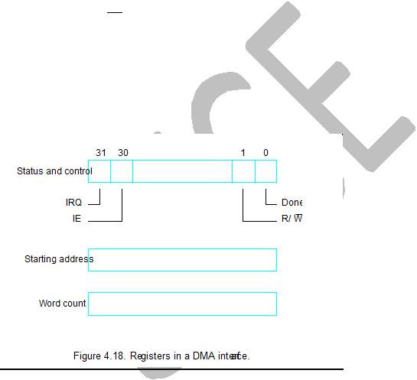

- The R/W bit determines the direction of the transfer. When this bit is set to 1 by a program instruction, the controller performs a read operation, that is, it transfers data from the memory to the I/O device. Otherwise, it performs a write operation.

- When the controller has completed transferring a block of data and is ready to receive another command, it sets the Done flag to 1.

- Bit 30 is the Interrupt-enable flag, IE. When this flag is set to 1, it causes the controller to raise an interrupt after it has completed transferring a block of data.

- IRQ – Interrupt request bit is set to 1 when it has requested an interrupt.

Use of DMA controllers in a computer system:

An example of a computer system is given in the below, showing how DMA controllers may be used.

A DMA controller connects a high-speed network to the computer bus.

The disk controller, which controls two disks, also has DMA capability and provides two DMA channels. It can perform two independent DMA operations, as if each disk had its own DMA controller. The registers needed to store the memory address, the word count, and so on are duplicated, so that one set can be used with each device.

13


Cycle stealing:

Memory accesses by the processor and the DMA controllers are interwoven. Requests by DMA devices for using the bus are always given higher priority than processor requests. Among different DMA devices, top priority is given to high-speed peripherals such as a disk, a high-speed network interface, or a graphics display device. Since the processor originates most memory access cycles, the DMA controller can be said to “steal” memory cycles from the processor. Hence, this interweaving technique is usually called cycle stealing. Alternatively, the DMA controller may be given exclusive access to the main memory to transfer a block of data without interruption. This is known as block or burst mode.

Block or burst mode:

Most DMA controllers incorporate a data storage buffer. In the case of the network interface, the DMA controller reads a block of data from the main memory and stores it into its input buffer. This transfer takes place using burst mode at a speed appropriate to the memory and the computer bus. Then, the data in the buffer are transmitted over the network at the speed of the network.

A conflict may arise if both the processor and a DMA controller or two DMA controllers try to use the bus at the same time to access the main memory, To resolve these conflicts, an arbitration procedure is implemented on the bus to co-ordinate the activities of all devices requesting memory transfers.

14

BUS ARBITRATION:

Bus master is the one who is currently sending data through system bus.

- Who is the bus master?
- How to select this bus master?
- Technique used – Bus Arbitration

The device that is allowed to initiate data transfers on the bus at any given time is called the bus master.

Bus arbitration is the process by which the next device to become the bus master is selected and bus mastership is transferred to it.
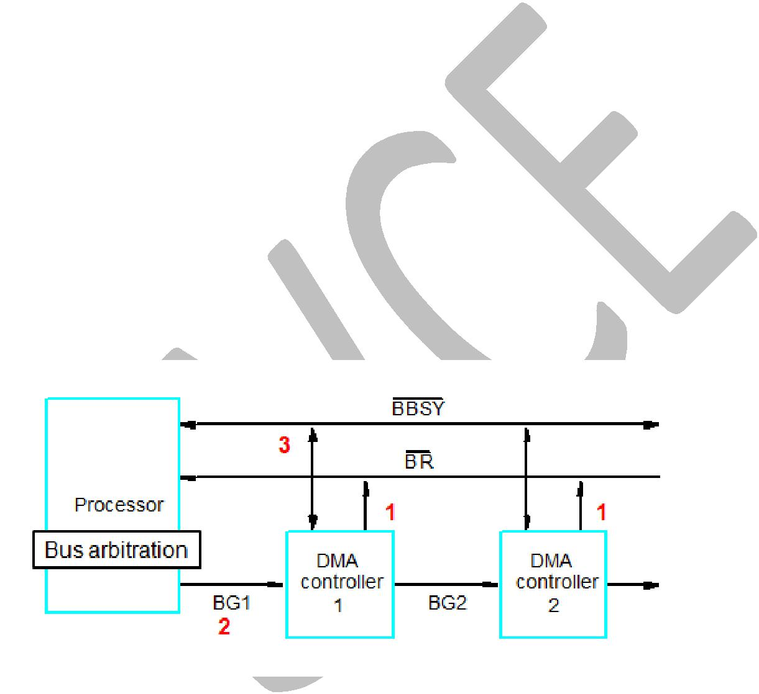

Two approaches: centralized and distributed

- Centralized - separate bus arbitration h/w

- Decentralized - no separate bus arbitration h/w

  - All the devices are involved in selecting the bus master.

Centralized arbitration:

In centralized arbitration, a single bus arbiter performs the required arbitration. The bus arbiter may be the processor or a separate unit connected to the bus.

The below figure, shows the basic arrangement in which the processor contains the bus arbitration circuitry.

- A DMA controller 1 and 2 indicates that it needs to become the bus master by activating the Bus-Request line, BR. The signal on the Bus-Request line is the logical OR of the bus requests from all the devices connected to it.

- When the Bus-Request is activated, bus arbitration circuitry activates the Bus-Grant signal, BG1, indicating to the DMA controllers that they may use the bus when it becomes free. This signal is connected to all DMA controllers using a daisy-chain arrangement. Thus, if the DMA controller 1 is requesting the bus, it blocks the propagation of the grant signal to other devices. Otherwise, it passes the grant downstream by asserting BG2.

15

- After receiving the Bus-Grant signal, a DMA controller 1 assumes the mastership to the bus and activates the Bus-Busy to prevent other devices from using the bus at the same time.

Distributed Arbitration:

Distributed arbitration, all devices participate in the selection of the next bus master.

Here, all devices waiting to use the bus have equal responsibility in carrying out the arbitration process, without using a central arbiter.

A simple method for distributed arbitration is illustrated in the below figure. Each device on the bus is assigned a 4-bit identification number. When one or more devices request the bus, they assert the Start-Arbitration signal and place their 4-bit ID numbers on four open-collector lines, ARB0 through ARB3. A winner is selected as a result of the interaction among the signals transmitted over these lines by all contenders. The net outcome is that the code on the four lines represents the request that has the highest ID number. An OR function is performed by the 4 open-collector lines.

16

Example: assume that two devices, A and B, having ID numbers 5 and 6, respectively are requesting the use of the bus. Device A transmits the pattern 0101 and device B transmits 0110. The code seen by both devices is 0111 (since 0101 OR 0110 = 0111). Each device compares the pattern on the arbitration lines to its own ID, starting from the most significant bit. If detects a difference at any bit position, it disables its drivers at that bit position and for all lower-order bits. It disables by placing 0 bit.

Ex: device A 0101 | device B 0110
0111 | 0111
----------- | ------------
0100 | 0110
----------- | -------------

Now the pattern on the arbitration lines is 0110 which means that B has own the contention.

The advantage of decentralized arbitration is higher reliablity, because operation of the bus is not dependent on any single device.

I/O INTERFACE:

An I/O interface consists of the circuitry required to connect an I/O device to a computer bus. On one side of the interface we have the bus signals for address, data and control. On the other side we have a data path with its associated controls to transfer data between the interface and the I/O device. This side is called a port, and it can be classified as either a parallel or a serial port.

A parallel port transfers data in the form of a number of bits, typically 8 or 16, simultaneously to or from the device.

A serial port transmits and receives data one bit at a time.

Communication with the bus is the same for both formats; the conversion from the parallel to the serial format, and vice versa, takes place inside the interface circuit.

Function of I/O Interface:

- Provide a storage buffer for at least one word of data;

- Contain status flags that can be accessed by the processor to determine whether the buffer is full or empty;

- Contain address-decoding circuitry to determine when it is being addressed by the processor;

- Generate the appropriate timing signals required by the bus control scheme;

- Perform any format conversion that may be necessary to transfer data between the bus and the I/O device.

17

Parallel port:

Transmits 8 bits or 16 bits per sec. Used in short distance communication. Ex: connecting RAM to processor

Serial port:

Transmits 1 bit per sec. Used in long distance communication. Ex: connecting Keyboard to Processor.

STANDARD I/O INTERFACES:

Why need standard I/O interfaces?

Specific interface can connect only a specific type of device to another device. Example: connects HP printer to Intel i7. Whereas, generic interface (standard I/O) can connect any type of device to any device. Example: connects any printer to any processor.

Processor bus: The bus defined by the signals on the processor chip itself. Devices require a very high speed connection to the processor, such as main memory, may be directly connected to this bus.

Expansion bus: The motherboard provides another bus that can support more devices. Devices connected to this bus appear to the processor as if they were connected directly to the processor’s own bus.

Bridge: The two buses are interconnected by a circuit called a bridge. It translates the signals and protocols of one bus into those of the other.

3 types of standard I/O interfaces:

- PCI – Peripheral Component Interconnect
- SCSI – Small Computer System Interface
- USB – Universal Serial Bus

The way these standards are used in a typical computer system is illustrated in the below figure. The PCI standard defines an expansion bus on the motherboard. SCSI and USB are used for connecting additional devices, both inside and outside the computer bus.

The SCSI bus is a high-speed parallel bus intended for devices such as disks and video displays.

The USB bus uses serial transmission to suit the needs of equipment ranging from keyboards to game controls to internet connection.

The figure also shows an interface circuit that enables devices compatible with the earlier ISA standard, such as the popular IDE (Integrated Device Electronics) disk, to be connected. It also shows a connection to an Ethernet.

18
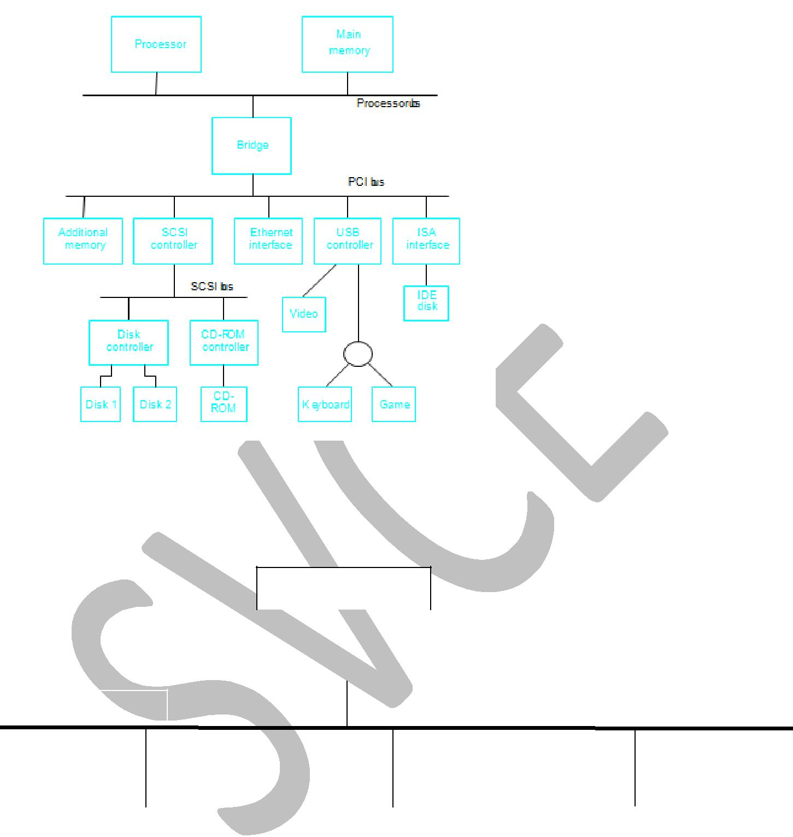

PCI - Peripheral Component Interconnect:

Devices connected to the PCI bus appear to the processor as if they were connected directly to the processor bus.

Plug-and-play capability is the advantage of PCI. To connect a new device, the user
simply connects the device interface The software takes care of the rest.
Host

 | PCI bridge |  |  | Main memory

PCI bus

Disk |  | Printer |  | Ethernet interface

The above figure shows the use of PCI bus in a computer system. The PCI bridge provides a separate physical connection for the main memory.

At any given time, one device is the bus master. It has the right to initiate data transfers by issuing read and write commands. A master is called an initiator in PCI terminology. This is

19

either a processor or a DMA controller. The addressed device that which responds to read or write commands is called the target.

SCSI - Small Computer System Interface:

A controller connected to a SCSI bus is one of two types.

- Initiator

- Target

An Initiator has the ability to select a particular target and to send commands specifying the operations to be performed. Clearly, the controller on the processor side, such as the SCSI controller in the figure 4.38, must be able to operate as an initiator.

The disk controller operates as a target. It carries out the commands it receives from the initiator.

The initiator establishes a logical connection with the intended target.

Once this connection has been established, it can be suspended and restored as needed to transfer commands and bursts of data.

SCSI - Data transfer:

Data transfers on the SCSI bus are always controlled by the target controller. To send a command to a target, an initiator requests control of the bus and, after winning arbitration, selects the target controller it wants to communicate with and hands control of the bus to it. Then the target controller starts a data transfer operation to receive a command from the initiator.

USB - Universal Serial Bus:

USB is a serial transmission of data. It offers 3 speeds of operation,

- Low-speed (1.5 megabits/s)
- Full-speed (12 megabits/s)
- High-speed (480 megabits/s) – USB 2.0

The USB has been designed to meet several key objectives:

- Provide a simple, low-cost, and easy to use interconnection system that overcomes the difficulties due to the limited number of I/O ports available on a computer.

- Accommodate a wide range of data transfer characteristics for I/O devices, including telephone and Internet connection.
- Enhance user convenience through a “plug-and-play” mode of operation.

Plug and play feature:

The plug and play feature means that a new device, such as an additional speaker can be connected at any time while the system is operating. The system should be able to detect the new device automatically, identify the appropriate device-driver software and any other facilities needed to service that device, and establish the appropriate addresses and logical connections to enable them to communicate.

20

USB architecture:

To accommodate, a large number of devices that can be added or removed at any time, the USB has the tree structure shown in the below figure.

Each node of the tree has a device called a hub, which acts as an intermediate control point between the host and the I/O devices. At the root of the tree, a root hub connects the entire tree to the host computer. The leaves of the tree are the I/O devices being served, which are called functions in USB terminology.
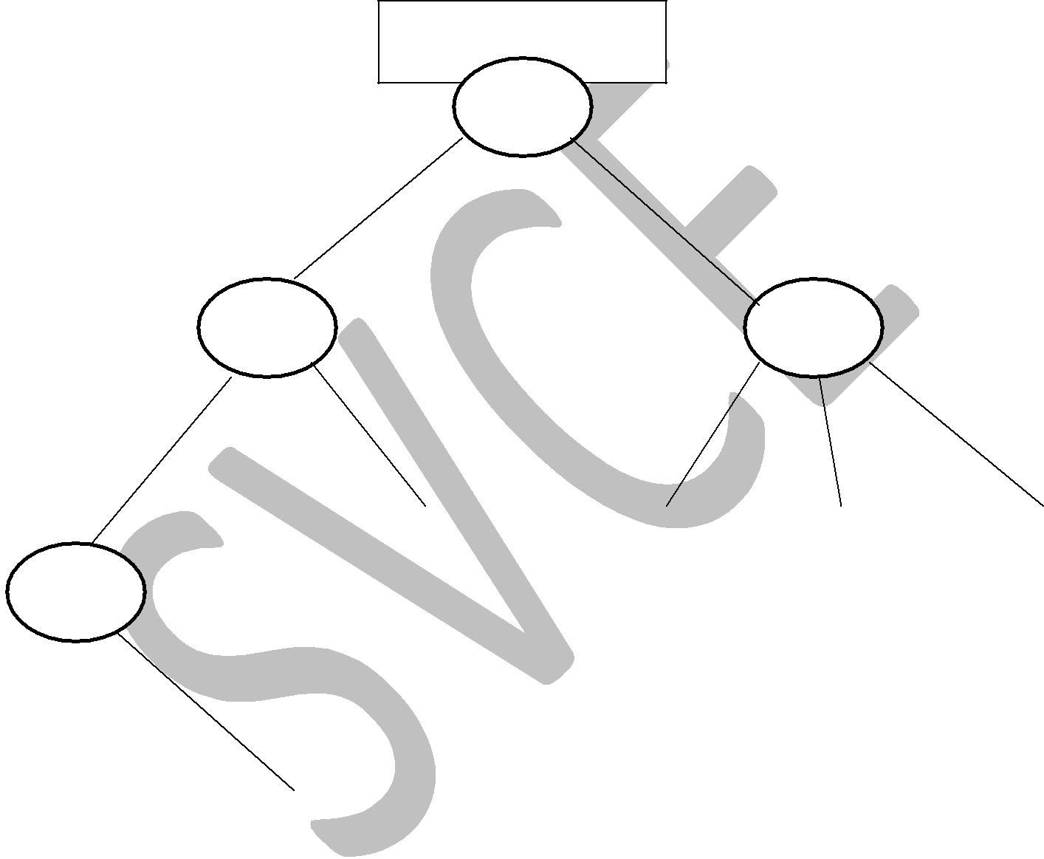

Host Computer

Root

hub

Root

hub

Root

hub

I/O device |  | I/O device |  | I/O device |  | I/O device

Root

hub

I/O device |  |  | I/O device

